Arts Researchers and Teachers Society
(Special Interest Group, Canadian Association for Curriculum Studies)
Annual General Meeting (2021)
May 29 at 2:30 to 4:30 Pm MDT
Agenda

- Approval of the Agenda
- Approval of the Minutes of the 2020 AGM meeting
- Opening remarks from the President (Ashwani Kumar):
- Reports from Executive & Members at Large
- President’s Report: Ashwani Kumar
I would like to start by thanking the members for attending the AGM. COVID-19 has had a significant impact on all of us on many levels, forcing last year’s conference to be cancelled and this year’s event to be held on-line. It took significant organisation, patience, and support to bring us to this point, and I would like to thank the membership, ARTS SIG executive, CACS executive, and CSSE conference organizers for all of their hard work which made this year’s conference possible.

After the cancellation of last year’s conference, and with no clear idea of what shape this year’s event would take, the ARTS SIG moved forward with planning this year’s conference, preparing for both an online and in-person event. Discussions were held on creating a gallery for Congress, and developing our own gallery on the ARTS SIG website. Based on the success of our “Artful Evening” at Congress 2019, we considered holding a similar on-line event this year but eventually decided against it because of logistical difficulties. Our hope is that we will hold one at Congress 2022 whether it proves to be an in-person or virtual event.

Roula Kteily-Hawa did a wonderful job organising the 2021 ARTS SIG conference in her role as Vice-President and Program Chair. She collaborated with other Program Chairs in work meetings which were organized and facilitated by Mike Holden and Tim Howard to create an exciting on-line conference. 24 ARTS sessions will take place in the conference this year on themes including aesthetic responses in a time of climate crisis; exploring community and activism through arts amidst COVID; Indigenous research and significance of understanding history; ethics, morality and art; and pedagogy research using arts-based methodologies, to name a few. Thanks so much, Roula, for your excellent work for the ARTS SIG.

Michelle J. Buckle and Bonnie Petersen, Preconference Co-Chairs, organised a very successful preconference, which many of you present here attended, around a timely theme of ARTS for Social Justice. ARTS members enthusiastically responded to the call for interactive and experiential presentations for this on-line event. We were fortunate to have Dr. Georgina Martin as our keynote speaker. After the event was organised, Michelle Buckle made the decision to withdraw from the conference in solidarity with the Black Canadian Studies Association. Michelle offered support to Bonnie and I as we finalized the details of this year’s preconference, however, due to circumstances beyond her control, Michelle decided to withdraw from her role as the preconference co-chair for the upcoming year. Bonnie and I would like to thank Michelle for her dedication and contributions to the ARTS SIG.

Émilie Vaillancourt and Tatiana Zakharova joined us as graduate student representatives this year. They have offered tremendous support by updating and maintaining our website— including a virtual gallery space—supporting member communication and translating documents from French into English. Due to their schedule, Émilie and Tatiana have withdrawn from serving on the ARTS SIG for the upcoming year. We will miss them both, but thank you so much, Émilie and Tatiana, for your contributions to the ARTS SIG.

Hala Mreiwid and Lisa Mitchell are coming to the end of two-year terms serving as exceptional Awards Chairs – Lisa as the Graduate Award Chair and Hala as the Publications Award Chair. Their hard work in creating calls, reviewing submissions, and determining winners was made more difficult by the pandemic scenario they were operating under. Thank you also to the reviewers that stepped forward to help them in their tasks. Later in the meeting, Hala and Lisa will announce the award winners. We will also hear brief presentations from the award winners. Thank you very much Hala and Lisa for your dedicated work for the ARTS SIG.

I am happy to inform you that Lisa has accepted to be the Virtual Art Gallery Coordinator for the upcoming year. Lisa will share her thoughts on this later.

The ARTS SIG currently has 89 members, including 41 students. Membership dues produced a revenue of $655.00. After paying out this year’s graduate student awards, and our preconference keynote, our account balance is $3,307.26

This year marks my first as President of the ARTS SIG after serving two years as the Vice-President and Program Chair. Despite the challenges imposed by COVID for me and for the ARTS SIG executive, I thoroughly enjoyed serving the ARTS SIG. As president, I had the opportunity to work closely with many of the people noted above, including Roula, Bonnie and Michelle, Hala and Lisa, and Émilie and Tatiana. I hope my contributions were valuable to them, but most of all, I was impressed and inspired by the enthusiasm they all brought to their respective roles. So, thank you again to all.
For the next year, we have added a number of positions to further streamline the work of the ARTS SIG as you might have noted from the call for ARTS SIG positions that was sent out via the ARTS’ email account. We will be appointing the new executive members later in the meeting.
I would like to inform you of the ARTS Presidential Keynote Panel in which three leading arts educators—Drs. Rita Irwin, Pauline Sameshima, Celeste Snowber—have kindly accepted my request to share their thoughts on the significance of artful teaching, learning, and living in the era of COVID-19 and beyond. I do hope you are able to attend the Presidential session tomorrow.
It was a pleasure to serve the amazing community of artists, researchers, and teachers and to work with talented and dedicated ARTS SIG executive members. I would like to especially mention the names of Laurel Hart (Past President) and Mindy Carter for their advice and help whenever I needed it. Their past experiences as the Presidents for ARTS SIG were hugely helpful. Thank you so much, Laurel and Mindy. I also want to thank CACS Co-Presidents, Kathryn Ricketts and Dawn Wiseman, for their leadership over the past year and for their time and help whenever I needed it.
I look forward to serving ARTS SIG again this year.

- Vice-President and Program Chair’s Report: Roula Hawa

This was my first year as ARTS SIG Vice President and Program Chair. It has been a pleasure to engage with such an inspiring community of artists, educators, and scholars. Through this role, I had the opportunity to meet and collaborate virtually with close to 25 Program Chairs in post-secondary institutions across Canada. I attended and actively participated in all Program Chairs’ work meetings which were organized and facilitated by Mike Holden and Tim Howard. I am very grateful for Mike’s support as I learned to navigate the duties for this fairly demanding position. In addition, I attended and actively participated in all ARTS SIG Executive meetings and contributed to other activities on the Executive. Some of my contributions included working with the pre-conference Chairs, Michelle Buckle and Bonnie Petersen and providing feedback on their call for pre-conference proposals. I also supported the Awards Chair, Hala Mreiwed by reviewing some of the paper submissions. What a rewarding learning experience!
Our ARTS program for the CSSE 2021 conference is looking healthy. Kudos to all the researchers, artists, scholars, graduate students, and practitioners in education who showed so much resilience and flexibility as we transitioned from what was supposed to be an in-person conference to a virtual conference. As we all tried hard to stay safe and healthy and maintain a work-life balance during the pandemic, finding peer reviewers presented some challenges. Nevertheless, a core group of reviewers from our ARTS SIG membership came through and provided a much-needed service. Thank you to all of our ARTS SIG members who served as peer reviewers and a shout-out to Bonnie and Hala on the Executive who came to the rescue for last-minute reviews.
In this year’s conference, we are running 24 ARTS sessions in total: 5 symposia/panel presentations, 3 of which are spotlight sessions, and 19 paper presentations. The presentations cover a wide range of arts-based and arts-informed themes and often address issues through an equity, diversity, inclusion, and decolonization lens. Some of the themes covered include: aesthetic responses in a time of climate crisis; exploring community and activism through arts amidst COVID; Indigenous research and significance of understanding history; ethics, morality and art; and pedagogy research using arts-based methodologies, to name a few.
The Vice-President and Program Chair role gave me the opportunity to learn more about the ARTS as a special interest group within the Canadian Association for Curriculum Studies. I enjoyed working with members of the ARTS team and serving the ARTS community. I look forward to continuing my service and to more exciting opportunities that come my way!
- Preconference Co-Chairs Report: Bonnie Petersen, Michelle Buckle
We want to begin by thanking and acknowledging the members we serve for their patience, kindness and support as we have navigated our way through the COVID-19 pandemic which required that we move the pre-conference online.
This has been a challenging time for everyone, especially as the events at home and abroad have underscored an ongoing commitment to condemning and combatting the impact of racism and discrimination against marginalized groups such as Indigenous people, Asians, and Blacks.
These global realities led us naturally to the theme of ‘Social Justice’ for the preconference day.
When the two of us first took on the roles of preconference chairs, no one knew for sure whether this year’s conference would be virtual or in-person. We began our roles by meeting with a few very helpful ARTS members—Laurel Hart, Hala Mreiwed, and Diane Conrad—to get advice based on past preconferences. Ideas for planning were quite complex initially, as we were trying to plan for both in-person and virtual participation.
When it became clear that the entire conference would be virtual, it also became clear that this would dictate our duties, that is, it would be made up of online administration rather than physical aspects like having to arrange physical spaces etc. This also meant that the timeline for our tasks was brought forward as we had to submit schedules and plans to the organisers in time for them to arrange online support. Luckily, when we sent out a call to members for participation in an experiential “ARTS for Social Justice” day, we received timely and enthusiastic response. We also received permission from the ARTS SIG to add a keynote speaker to the day, Dr. Georgina Martin.
In consideration of the harm caused by earlier incidents of anti-black racism within the Congress, and the lack of positive change that had taken place thus far, the Black Canadian Student Association decided to withdraw from Congress 2021. Some other groups and individuals, including members of the ARTS-SIG, also opted to withdraw in solidarity and support of this position. The ARTS SIG itself decided to move ahead with participation in Congress, aligning with Canadian Association of Curriculum Studies, and in light of our preconference theme, but we gave careful consideration to how we could rearrange our day to address this issue in some way. Our final decision was to create a space for ARTS members, including periods of silence, for discussion and sharing around the topic, to allow us to address the underlying issues and their impacts in some way.
At the time of writing, the preconference day has yet to take place. Best wishes to all of us for the day!
- Publication Award Chair’s Report: Hala Mreiwed
This year, we received 11 diverse and strong entries that were reviewed by 11 expert reviewers with each reviewing 1-3 submissions. Two submissions tied for first place based on the evaluation criteria; they were:
- Title: Reconceptualizing teacher identity through design thinking: A Montreal case study.
Authors: Mindy R. Carter, Brett Fischer, Layal Shuman, Sean Wiebe, Patrick Howard, Pauline Sameshima, Peter Gouzouasis, Katherine Ricketts, Mitch McLarnon.

Full citation:
Carter, M. R., Fischer, B. Shuman, L., Wiebe, S., Howard, P., Sameshima, P., Gouzouasis, Ricketts, K., & McLarnon, M. (2020). Reconceptualizing teacher identity through design thinking: A Montreal case study. Canadian Art Teacher, 17(1), 26-38.

- Title: Staging Therapeutic Enactment with Veterans in Contact! Unload
Authors: Graham W. Lea, George Belliveau, Marv Westwood

Full citation:
Graham W. Lea , George Belliveau & Marv Westwood. (2020). Staging Therapeutic Enactment with Veterans in Contact! Unload, Qualitative Research in Psychology, 17(4), 521-540, DOI: 10.1080/14780887.2018.1442776

The first authors of the awarded publications were informed; an official announcement will me made during the AGM. As my 2-year term has come to an end, I am looking forward to helping the upcoming Publication Awards Chair.
A suggestion from one of the reviewers for consideration:
Making “space for categories of awards” such as ABER within theatre, creative fiction, dance, music, and multi-arts (for those that include more than one art form). As this “may open the door to recognizing more talent, more work.”

- Graduate Award Chair’s Report: Lisa Mitchell

The call for graduate awards submissions was posted on the ARTS website and made public via appropriate listservs with large Arts-based membership (e.g., CSSE CACS, ARTS, and other university-specific graduate lists) in November of 2020. After revising the previous year’s call for submissions, the updated call was posted and circulated in both English and French. A panel of volunteer reviewers from across the Arts- based teaching and research community in Canada was assembled via individual invitation by myself, the awards Chair. The closing date for awards submissions was February 14th, 2021.
For the 2020 call, I received three eligible PhD submissions and zero Master’s submissions by the competition closing date. The PhD submissions represented work from doctoral students at three universities: The University of British Columbia (UBC), Concordia University, and McGill University, respectively. The cross-section of submissions drew from (but were not limited to) Arts-based research in the areas of Photography, Urban Arts, Self-Study, Visual/Fine Arts, Critical Curation, Social Justice, Memory Work, Narrative Storytelling, and Indigenous Arts. Each submission was reviewed by at least two reviewers and feedback and rankings were sent in confidence to me as Chair.
Ultimately, after tallying the review rankings and considering the qualitative feedback, it was decided that one award would be given at the PhD level to Dr. Blake E. Smith (UBC) for her outstanding dissertation entitled, Being Against Disappearance: A Photographic Inquiry Through an A/r/tographic Lens. Dr. Smith has been presented with a certificate acknowledging this achievement and a monetary prize of $200.
- Graduate Student Representatives’ Reports: Emily Vaillancourt, Tatiana Zakharova

Émilie Vaillancourt
This year, my primary engagement with the ARTS SIG has been to ensure an active communication between all members. My responsibilities included occasionally sending out pre-drafted emails via the listserv, checking the ARTSSIG email periodically, attending ARTSSIG virtual meetings (and providing an update if necessary) and translating documents from English into French.

Tatiana Zakharova

Since joining ARTS SIG in June 2020, my primary engagement has been in updating and maintaining ART SIG website http://artssig.ca/

- Website overall design has been updated to achieve a mode modern look
- Website navigation has been streamlines for better user experience
- Website has been updated with information made available by the Executive Committee (eg: bios & photos of the 2020-2022 executive team; AGM 2020 minutes; pre-conference program, etc)
- Out-of-date information has been formatted accordingly; for example, artwork submitted prior to 2019 has been combined into a single Gallery Archive.
- Space for new Virtual Gallery has been set up
- Additional changes has been made in response to user feedback (eg: How to join ARTS SIG instructions; removal of email address that wasn’t being maintained; streamline of contact info)
I can further report that, the web traffic to ARTS SIG site has increased significantly since July
2020:

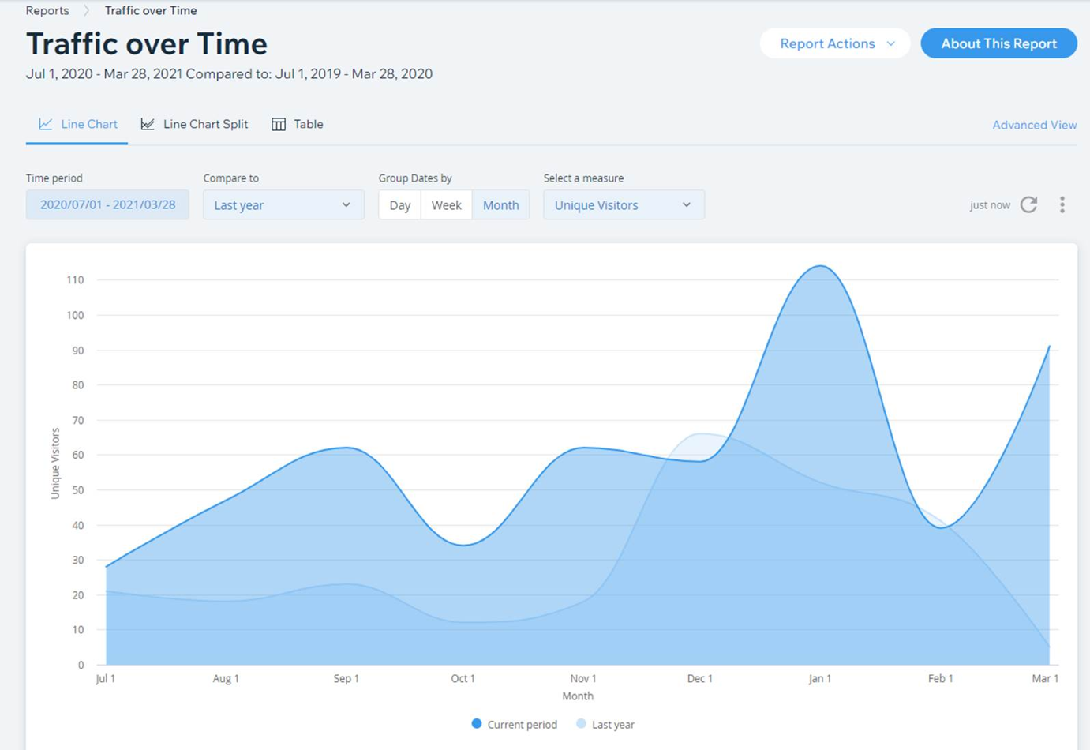

- Publications Award Presentations

- Graduate Awards Presentations:

- Election & “Changing of the Guard”
  - Virtual Art Gallery Coordinator

- New Business Arising
  - Proposal for two new awards (Life-time Achievement Award and Emerging Researcher’s Award) by Bernie Andrews
- Announcements
- Adjournment
ARTS SIG Executive 2021-22
President: Ashwani Kumar

Vice President: Roula Kteily-Hawa
Preconference Co-Chairs: Bonnie Petersen
Publication Awards Chair: Layal Shuman, Katie Tremblay
Graduate Research Awards Chair: Traci Klein
Virtual Art Gallery Curator: Lisa Mitchell
Graduate Student Representatives
Communications: Iain MacLeod
Website Organizer: Jax Stendel
Meeting Organizer: Marta Cotrim

